Core16 Hall Sensor Placement V0.2 (2023-09-19)

The hall sensors are installed on the Back Side (AKA The Dark Side). Each one has only one position it can be in to work correctly because they all have unique I2C IDs. Once they are removed from the packaging you can no longer identify which is which.

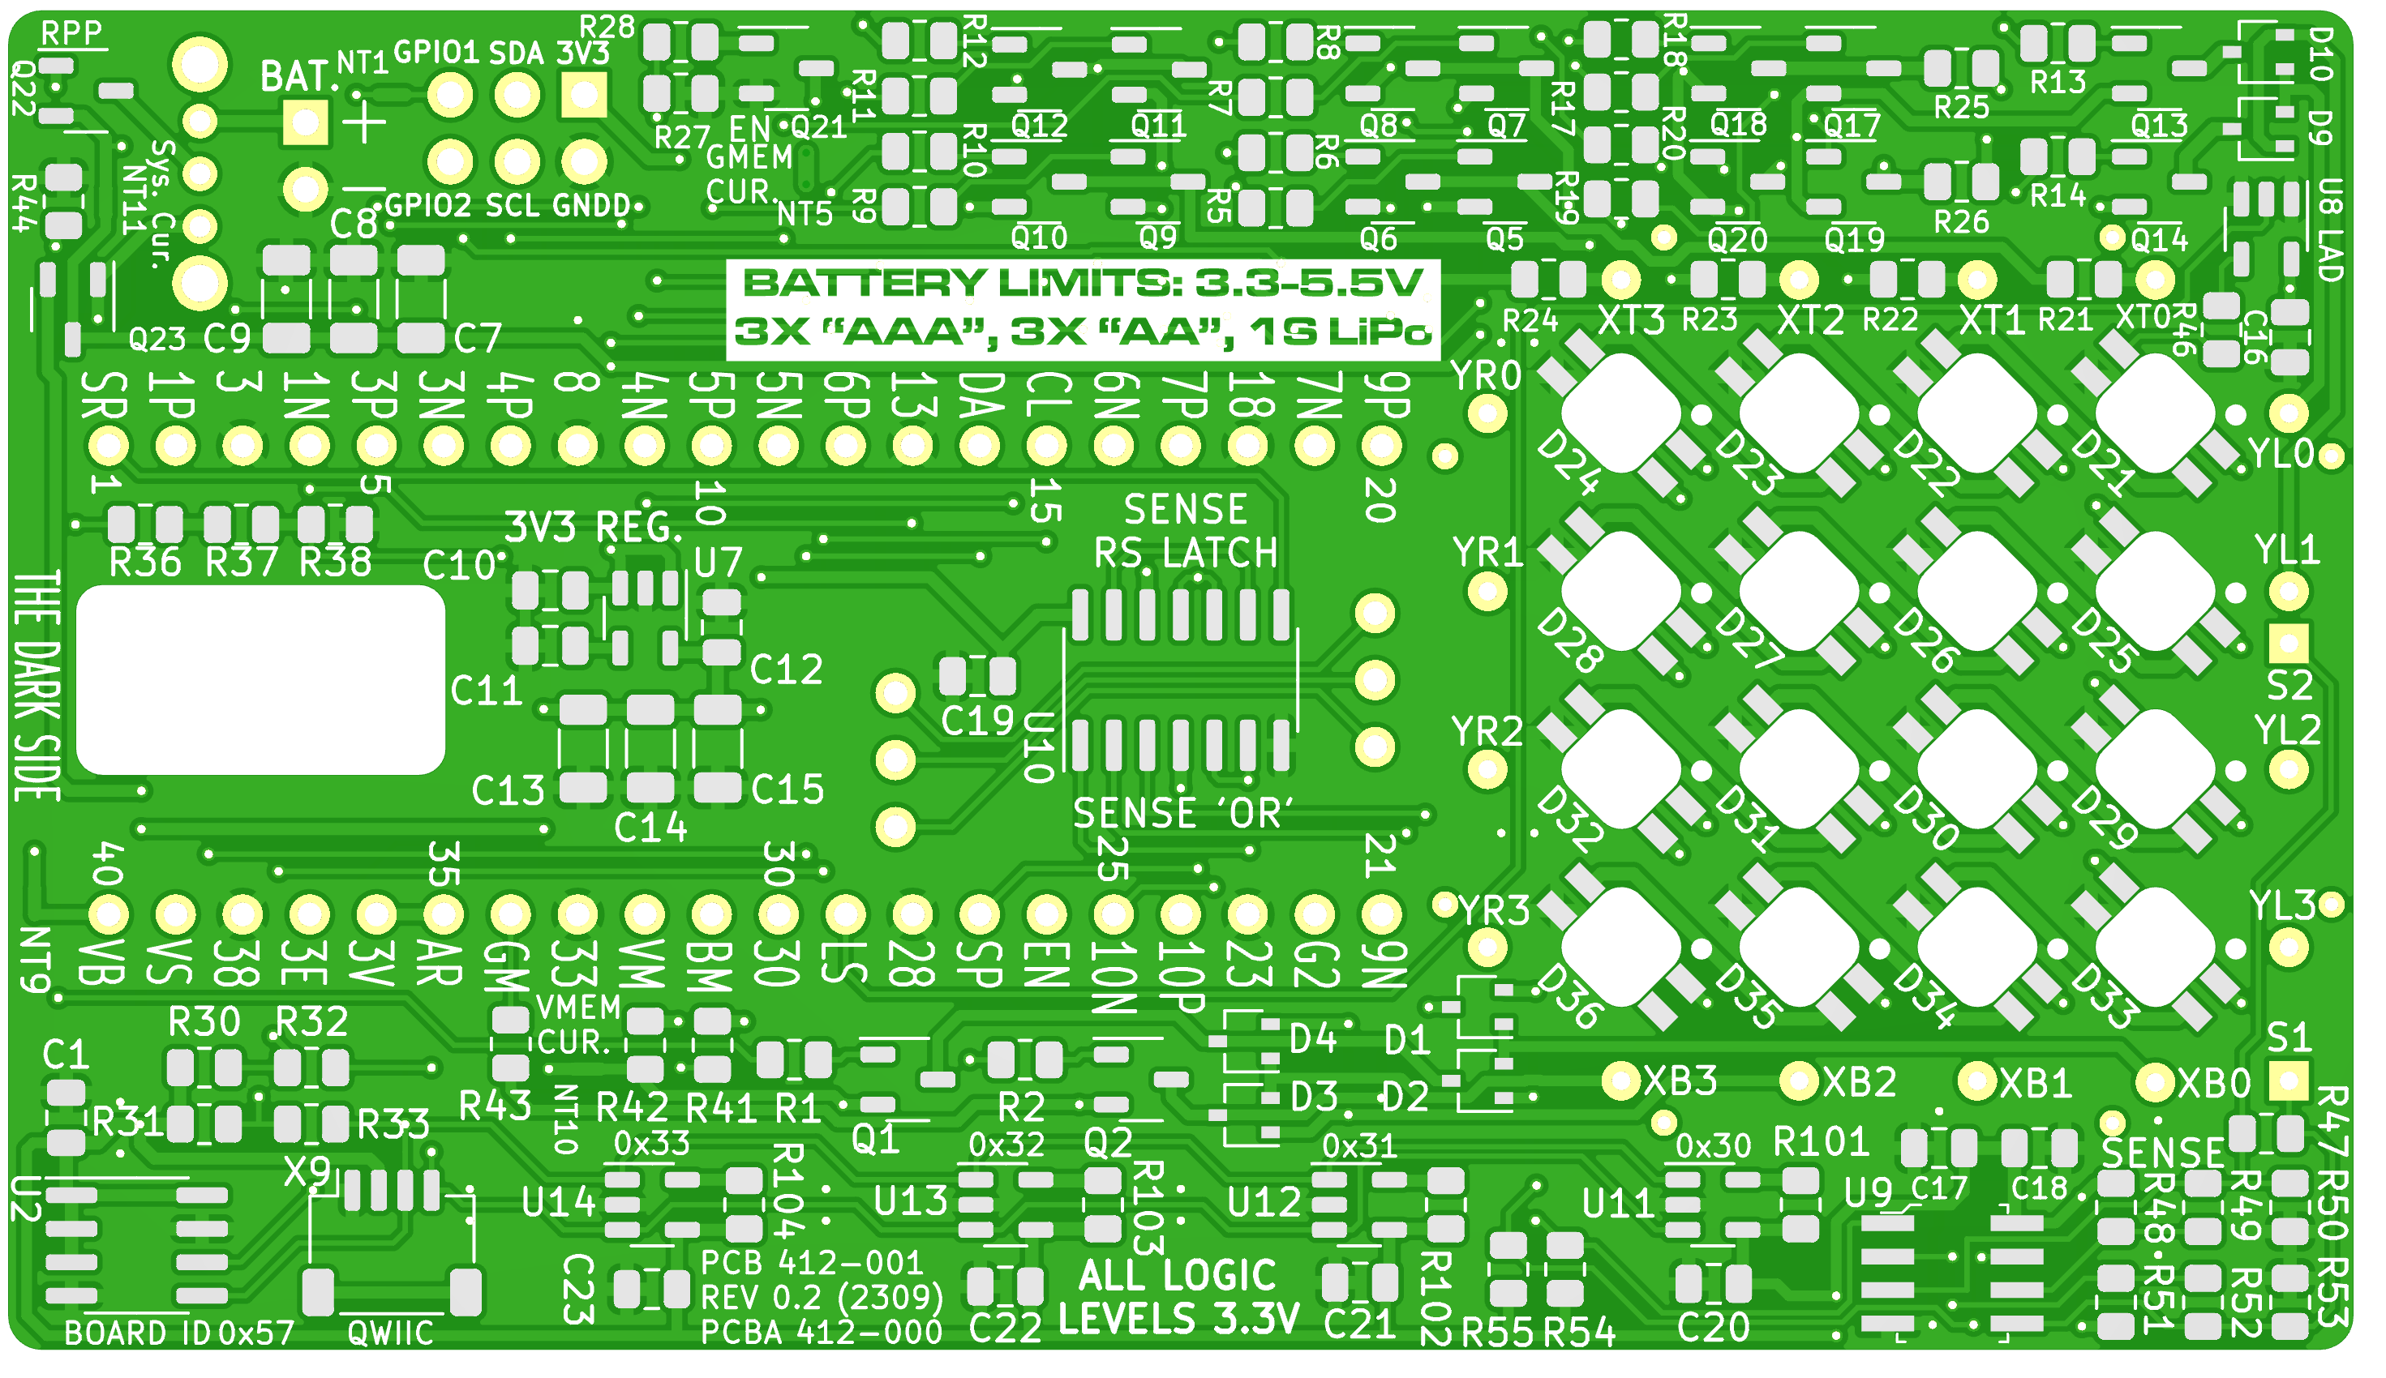

S + - M

4 3 2 1

P/N SI7210-B- -04 -03 -02 -00

For reference, this is the Front Side (AKA The Light Side)

